The Marketing and Promotions Plan (M&PP) is for;
A retailer to explain to Rail Delivery Group how it intends to promote the sale of Rail Products to the benefit of the industry reputation and customers, and how it intends to contribute to industry growth
To provide a point of reference against which Rail Delivery Group can audit the retailer’s compliance with their Licence agreement.

Confidentiality
The contents of the Marketing and Promotions Plan (M&PP) will be confidential to Rail Delivery Group and the retailer. No other parties have any rights to view the M&PP.

Approval
The M&PP will be assessed by Rail Delivery Group and deemed acceptable unless Rail Delivery Group can demonstrate that it fails to meet the Specification, the Standards or any other Licence condition.

Specification
The ‘M&PP’ must set out as a minimum:
- The Method(s) of Retailing and Site(s) through which National Rail Products will be made available for sale;
- The estimated total value of the sales of Rail Products forecast to be achieved during the term the plan applies to in respect of each Method of Retailing. The sales forecast needs to be broken down into each retailing method e.g. Public Internet Site, Mobile Retailing etc.
- The estimated sales forecast needs to be broken down into each Market segment e.g. Business, Leisure, Commute etc. and by Target Group such as Students/Seniors etc. and by geographical area of London, Southeast, Berks, Kent, Channel Isle etc.
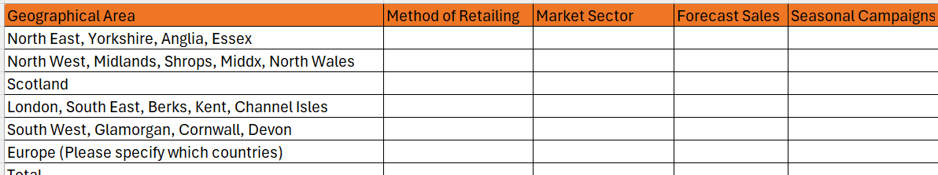
- Details of intended promotions during the term of the plan including proposed dates, an estimate of sales volume and the estimated value of sales.
- Please advise if your promotions are expected to increase demand during certain periods and in certain routes? If so, can we facilitate a conversation with TOC(s) to assist in preparing for the forecasted increase in demand.
- Details of the market sectors to be targeted (i.e. business, leisure) and a description of the geographical areas to be covered.
- Whether or not it is intended to:
- Offer Rail Products for sale at discounted prices including details of how discounting would be applied (the Applicant should note the provisions relating to the levels of discounts - see clause 5.8 of the TPIL template);
- Offer other services in competition to the provision of Train Service information and the sale of Rail Products.

- How it is intended to:
- Ensure that sufficient resources (both in terms of systems and staff) are provided to meet the objectives of the plan and to satisfy the RDG Standards;
- Ensure that staff employed are trained to meet the RDG Standards and any National Rail training standard that might apply from time to time.

